WAFI
WATER FOR ALL INITIATIVE
Our vision is to see the end to lack of safe water, clean toilets, and good hygiene everywhere in the world
Our Mission
Immediate resolution of the crisis of access to water, sanitation and hygiene services in many parts of the world
Ensuring that vulnerable peoples of the world do not lack basic WASH services regardless
Support every process to insulate world population acesss to WASH services from climate change variability
Approach
Advocacy for best practice and more inclusive approaches to WASH service delivery
Advocacy for prioritization of WASH funding by governments and philanthropic organizations including CSR of corporate giants
Coordinating a platform to mobilize resources through blended finance to fund process
Global Score Card
703 million people – almost one in ten – don’t have clean water close to home
1.5 billion people – almost one in five – don’t have a decent toilet of their own
Almost 2 billion people – one in four – can't wash their hands with soap at home
More than 1,000 children under five die every day due to diseases caused by unsafe water, sanitation and hygiene
the global promise made in the Sustainable Development Goals for everyone, everywhere to have access to safe and lasting water and sanitation and basic hygiene by 2030
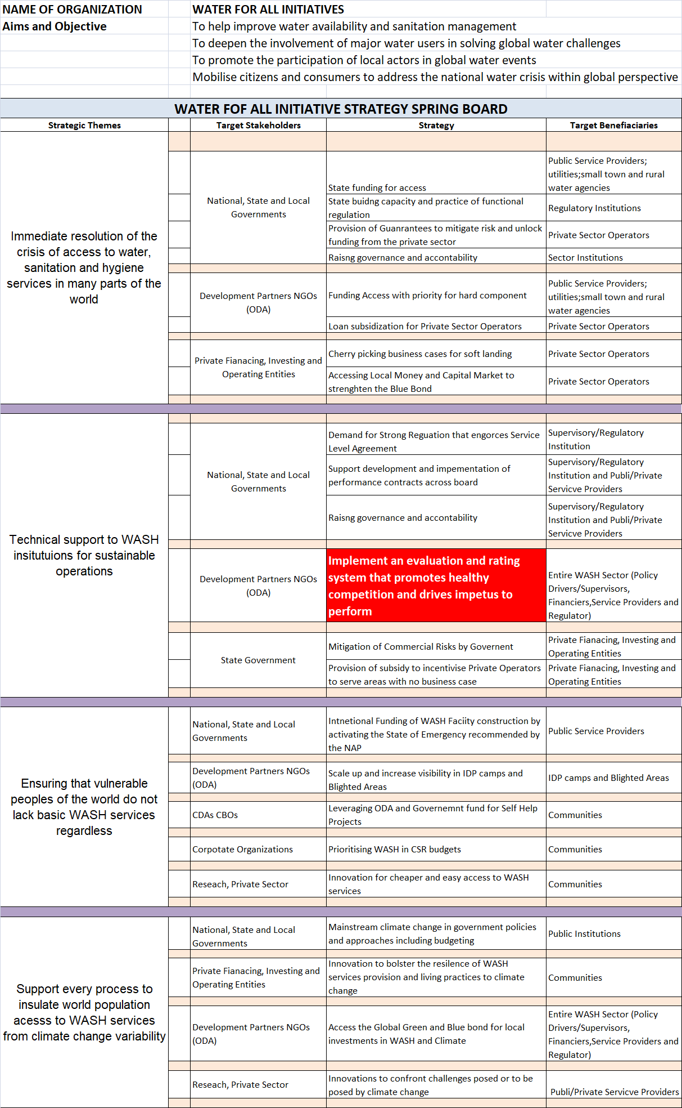

NAME OF ORGANIZATION |  | WATER FOR ALL INITIATIVES
Aims and Objective |  | To help improve water availability and sanitation management
 |  | To deepen the involvement of major water users in solving global water challenges
 |  | To promote the participation of local actors in global water events
 |  | Mobilize citizens and consumers to address the national water crisis within global perspective
WATER FOF ALL INITIATIVE STRATEGY SPRING BOARD
Strategic Themes |  | Target Stakeholders | Strategy | Target Benefiaciaries
Immediate resolution of the crisis of access to water, sanitation and hygiene services in many parts of the world
 |  | National, State and Local Governments | State funding for access | Public Service Providers; utilities ;small town and rural water agencies
 |  | National, State and Local Governments | State boding capacity and practice of functional regulation | Regulatory Institutions
 |  | National, State and Local Governments | Provision of Guarantees to mitigate risk and unlock funding from the private sector | Private Sector Operators
 |  | National, State and Local Governments | Raising governance and accontability | Sector Institutions
 |  | Development Partners NGOs (ODA) | Funding Access with priority for hard component | Public Service Providers; utilities; small town and rural water agencies
 |  | Development Partners NGOs (ODA) | Loan subsidization for Private Sector Operators | Private Sector Operators
 |  | Private Financing, Investing and Operating Entities | Cherry picking business cases for soft landing | Private Sector Operators
 |  | Private Financing, Investing and Operating Entities | Accessing Local Money and Capital Market to strengthen the Blue Bond | Private Sector Operators
Technical support to WASH insitutuions for sustainable operations
 |  | National, State and Local Governments | Demand for Strong Regulation that enforces Service Level Agreement | Supervisory/Regulatory Institution
 |  | National, State and Local Governments | Support development and implementation of performance contracts across board | Supervisory/Regulatory Institution and Public/Private Service Providers
 |  | National, State and Local Governments | Raising governance and accountability | Supervisory/Regulatory Institution and Publi/Private Service Providers
 |  | Development Partners NGOs (ODA) | Implement an evaluation and rating system that promotes healthy competition and drives impetus to perform | Entire WASH Sector (Policy Drivers/Supervisors, Financiers, Service Providers and Regulator)
 |  | State Government | Mitigation of Commercial Risks by Government | Private Financing, Investing and Operating Entities
 |  | State Government | Provision of subsidy to incentivise Private Operators to serve areas with no business case | Private Financing, Investing and Operating Entities
Ensuring that vulnerable peoples of the world do not lack basic WASH services regardless |  | National, State and Local Governments | Intentional Funding of WASH Facility construction by activating the State of Emergency recommended by the NAP | Public Service Providers
 |  | Development Partners NGOs (ODA) | Scale up and increase visibility in IDP camps and Blighted Areas | IDP camps and Blighted Areas
 |  | CDAs CBOs | Leveraging ODA and Government fund for Self Help Projects | Communities
 |  | Corporate Organizations | Prioritizing WASH in CSR budgets | Communities
 |  | Research, Private Sector | Innovation for cheaper and easy access to WASH services | Communities
Support every process to insulate world population acesss to WASH services from climate change variability |  | National, State and Local Governments | Mainstream climate change in government policies and approaches including budgeting | Public Institutions
 |  | Private Financing, Investing and Operating Entities | Innovation to bolster the resilience of WASH services provision and living practices to climate change | Communities
 |  | Development Partners NGOs (ODA) | Access the Global Green and Blue bond for local investments in WASH and Climate | Entire WASH Sector (Policy Drivers/Supervisors, Financiers, Service Providers and Regulator)
 |  | Research, Private Sector | Innovations to confront challenges posed or to be posed by climate change | Publi/Private Servicve Providers

You can learn or or two things from the design below to do our own
